**BURGERHUT WIREFRAME**

MockFlow Link: <https://wireframepro.mockflow.com/view/MQn0AO7e7h>

**INDEX PAGE**

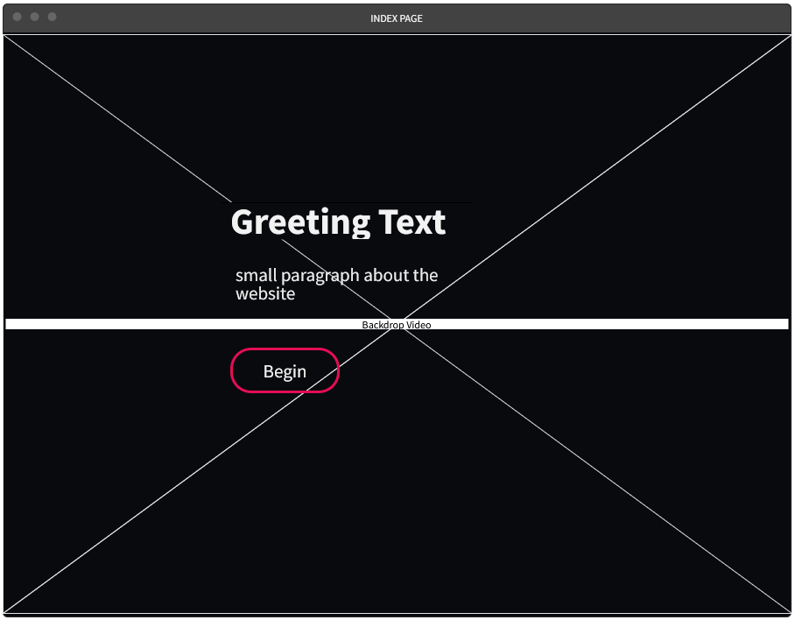

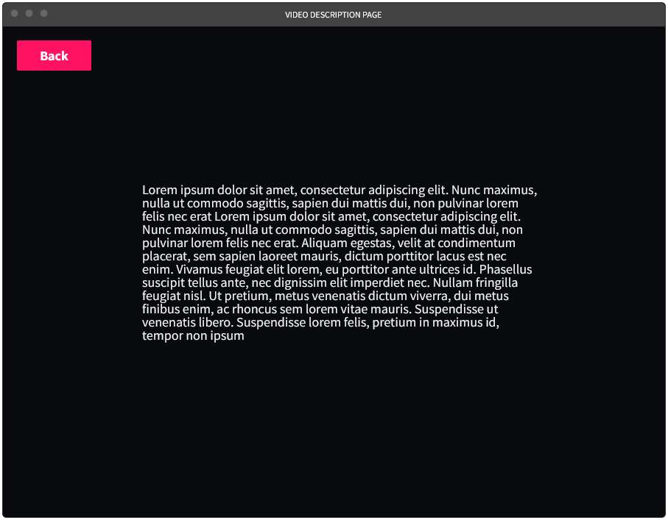**VIDEO DESCRIPTION PAGE**

**SHOP PAGE**

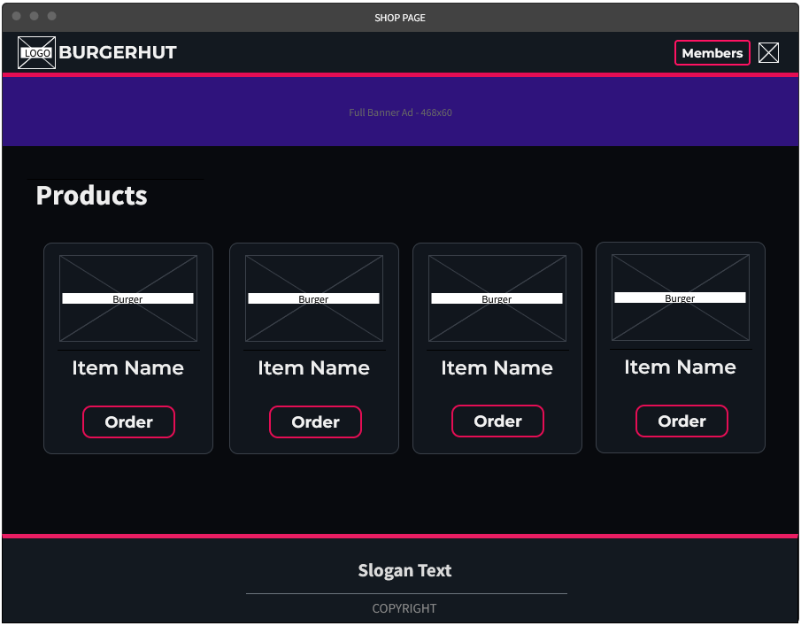

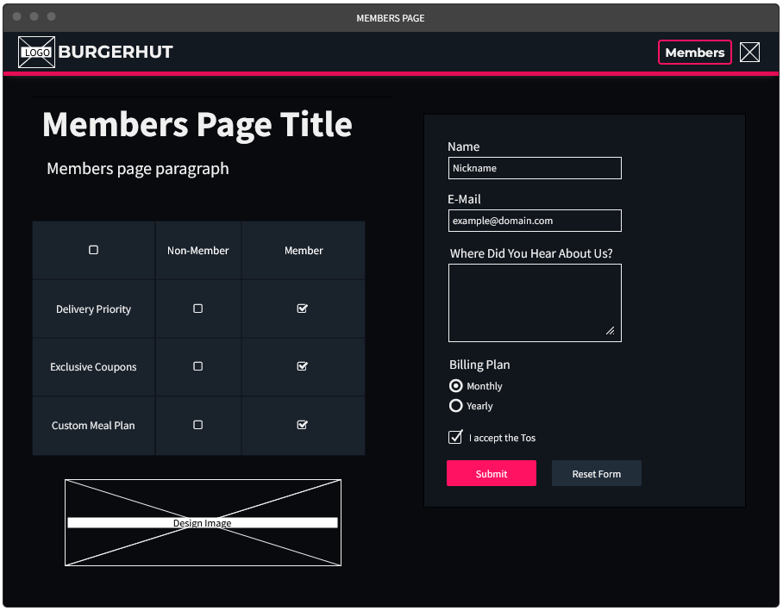**MEMBERS PAGE**